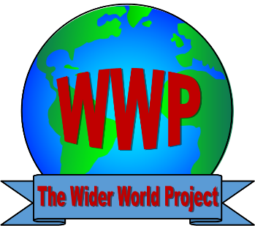
Wider World Project
Special Educational Needs Policy

Policy Statement

The Wider World Project aims to provide a safe, caring and welcoming environment where young people and adults (age 16-35) can engage in positive activities.
The Project encourages a learning environment to promote important life skills and the opportunity to gain accreditation and personal achievement .
Members will be given opportunities to take part in a diverse range of activities and projects that will promote learning and development and raise aspirations.

Special Educational Needs
The definition of a person having special educational needs is ‘if they have a learning difficulty that calls for special educational provision to be made for them’.

A person has a learning difficulty if they:
- Have a significantly greater difficulty in learning than the majority of people the same age.
- Have a disability that prevents or hinders them from making use of educational facilities of a kind generally provided for young people of the same age in schools within the area of the local education authority.

Membership
The Wider World Project is a provision for young people with additional needs age 16-35 years living in County Durham. Our Clubs and Projects are predominantly for but not exclusive to young people with learning disabilities and we welcome all young people to attend.

Parents/Carers
Parents/Carers are encouraged to liaise with staff to provide information and advice on their son/daughter to ensure their needs are supported within the clubs and projects.

Members
All members will be encouraged to participate in the planning of activities and will be part of the decision-making processes.

Staff Training
All staff will attend relevant training to support their role working with children and adults with special educational needs.

